**Control Structures**

**Scenario 1:** The bank wants to apply a discount to loan interest rates for customers above 60 years old.

CREATE TABLE customers (

customer_id INTEGER PRIMARY KEY,

name VARCHAR2(100),

age NUMBER,

balance NUMBER

);

CREATE TABLE loans (

loan_id NUMBER PRIMARY KEY,

customer_id NUMBER,

interest_rate NUMBER,

FOREIGN KEY (customer_id) REFERENCES customers(customer_id)

);

BEGIN

INSERT INTO customers VALUES (1, 'Alice', 65, 12000 );

INSERT INTO customers VALUES (2, 'Bob', 45, 8000);

INSERT INTO customers VALUES (3, 'Charlie', 70, 15000);

INSERT INTO customers VALUES (4, 'Diana', 99, 500);

INSERT INTO loans VALUES (101, 1, 5.5);

INSERT INTO loans VALUES (102, 2, 6.0);

INsERT INTO loans VALUES (103, 3, 4.8);

INSERT INTO loans VALUES (104, 4, 7.0);

COMMIT;

END;

/

BEGIN

FOR rec IN (

SELECT l.loan_id, l.interest_rate

FROM loans l

JOIN customers c ON l.customer_id = c.customer_id

WHERE c.age > 60

) LOOP

UPDATE loans

SET interest_rate = interest_rate - 0.01

WHERE loan_id = rec.loan_id;

DBMS_OUTPUT.PUT_LINE('Discount applied to Loan ID ' || rec.loan_id);

END LOOP;

COMMIT;

END;

/

OUTPUT:

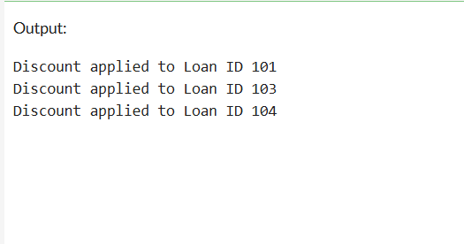

**Scenario 2:** A customer can be promoted to VIP status based on their balance.

CREATE TABLE customers (

customer_id INTEGER PRIMARY KEY,

name VARCHAR2(100),

age NUMBER,

balance NUMBER,

is_vip CHAR(1) DEFAULT 'N'

);

CREATE TABLE loans (

loan_id NUMBER PRIMARY KEY,

customer_id NUMBER,

interest_rate NUMBER,

FOREIGN KEY (customer_id) REFERENCES customers(customer_id)

);

BEGIN

INSERT INTO customers VALUES (1, 'Alice', 65, 12000,'N');

INSERT INTO customers VALUES (2, 'Bob', 45, 8000,'N');

INSERT INTO customers VALUES (3, 'Charlie', 70, 15000,'N');

INSERT INTO customers VALUES (4, 'Diana', 99, 500,'N');

INSERT INTO loans VALUES (101, 1, 5.5);

INSERT INTO loans VALUES (102, 2, 6.0);

INsERT INTO loans VALUES (103, 3, 4.8);

INSERT INTO loans VALUES (104, 4, 7.0);

COMMIT;

END;

/

BEGIN

FOR rec IN (

SELECT customer_id FROM customers WHERE balance > 10000

) LOOP

UPDATE customers

SET is_vip = 'Y'

WHERE customer_id = rec.customer_id;

DBMS_OUTPUT.PUT_LINE('Customer ID ' || rec.customer_id || ' set as VIP');

END LOOP;

COMMIT;

END;

/

OUTPUT:

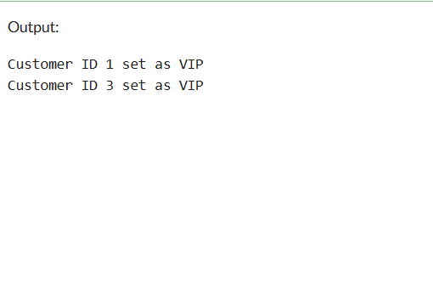

**Scenario 3:** The bank wants to send reminders to customers whose loans are due within the next 30 days  
CREATE TABLE customers (

customer_id INTEGER PRIMARY KEY,

name VARCHAR2(100),

age NUMBER,

balance NUMBER,

is_vip CHAR(1) DEFAULT 'N'

);

CREATE TABLE loans (

loan_id NUMBER PRIMARY KEY,

customer_id NUMBER,

interest_rate NUMBER,

due_date DATE,

FOREIGN KEY (customer_id) REFERENCES customers(customer_id)

);

BEGIN

INSERT INTO customers VALUES (1, 'Alice', 65, 12000,'N');

INSERT INTO customers VALUES (2, 'Bob', 45, 8000,'N');

INSERT INTO customers VALUES (3, 'Charlie', 70, 15000,'N');

INSERT INTO customers VALUES (4, 'Diana', 99, 500,'N');

INSERT INTO loans VALUES (101, 1, 5.5, SYSDATE + 10); -- Due soon

INSERT INTO loans VALUES (102, 2, 6.0, SYSDATE + 40); -- Not due soon

INSERT INTO loans VALUES (103, 3, 4.8, SYSDATE + 5); -- Due soon

INSERT INTO loans VALUES (104, 4, 7.0, SYSDATE + 25); -- Due soon

COMMIT;

END;

/

BEGIN

FOR rec IN (

SELECT l.loan_id, c.name, l.due_date

FROM loans l

JOIN customers c ON l.customer_id = c.customer_id

WHERE l.due_date BETWEEN SYSDATE AND SYSDATE + 30

) LOOP

DBMS_OUTPUT.PUT_LINE('Reminder: Loan ' || rec.loan_id ||' for customer ' || rec.name ||' is due on ' || TO_CHAR(rec.due_date, 'YYYY-MM-DD'));

END LOOP;

END;

/

